

Structural Design

(Inside View)

**Vertical corrugation**

 191*/*4 

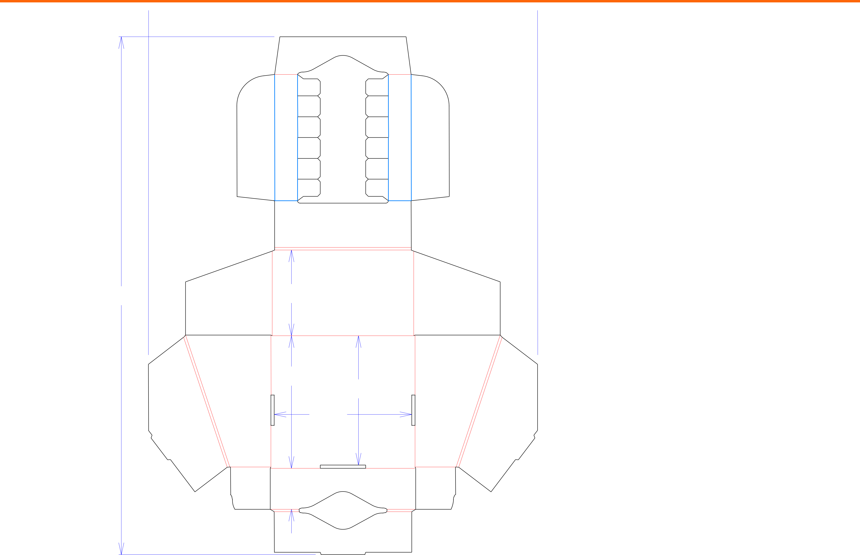

|  |  |  |  |
| --- | --- | --- | --- |
| 2511*/*16 | 41*/*4 |  |  |
|  | 69*/*16 | 67*/*16 |  |
|  |  |  |
|  |  | 613*/*16 |  |
|  | 21*/*16 |  |  |

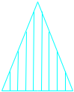

Design#:

**200273-01**

Customer:

**DeMet's Candy**

Description:

**Turtles Tray w/HSC- 6ct/2.9oz Heart Boxes**

**SINGLE-OUT DRAWING**

Qty/Unit:

Style: **NJDC**

Board: **32EW**

Combination: **36MW - 23M - 35HP**

I.D. : **13+9/16 x 6+5/16 x 4+9/16**

Area of Blank - Waste : **2.02 sq. ft.**

Waste on Blank : **41.19%**

Finished Piece Weight: **0.22 lbs./101.13g**

Over-all Blank: **25+21/32 x 19+1/4**

Notes:

Revision Info: **[0] 04/14/2020**

Designer: **Amy Kirchhoff**

Cut Crease Crease with Matrix Cut Crease Half Knife Cut Tear Tape Perforation



Designright and Copyright of DS Smith Corrugated Packaging Ltd. This technical Specification is subject to Manufacturing tolerances. Drawing dimensions shown are crease to crease. Date printed: 04/14/2020